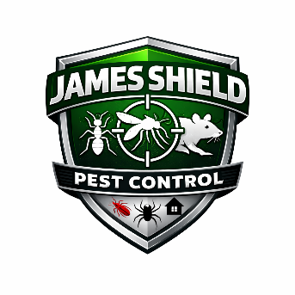
James Shield Pest Control
Safety & Personal Protective Equipment (PPE) Policy

1. Purpose
The purpose of this policy is to ensure the health and safety of all employees, customers, and the public through proper use of Personal Protective Equipment (PPE) and adherence to safe work practices in accordance with OSHA standards, EPA regulations, and state pesticide laws.
Safety is a core value at James Shield Pest Control. No service call is more important than employee safety.

2. Policy Statement
James Shield Pest Control requires all employees to:
- Follow all OSHA safety standards.
- Use required PPE as specified by pesticide labels and Safety Data Sheets (SDS).
- Follow company safety procedures at all times.
- Immediately report unsafe conditions.
Failure to comply may result in disciplinary action up to and including termination.

3. Scope
This policy applies to:
- Licensed applicators
- Technicians
- Supervisors
- Warehouse staff
- Administrative staff handling chemicals
- Any employee exposed to pesticide products

4. Required Personal Protective Equipment
PPE requirements are determined by product label instructions and job tasks.
Minimum Standard Field PPE (unless label requires more):
- Long-sleeved shirt
- Long pants
- Closed-toe, chemical-resistant footwear
- Chemical-resistant gloves
- Protective eyewear (goggles or safety glasses)

Additional PPE (as required by label or task):
- Respirator (NIOSH-approved, properly fit tested)
- Face shield
- Chemical-resistant apron
- Tyvek suit or chemical-resistant coveralls
- Head protection
- Hearing protection (when using power equipment)

5. Respiratory Protection
When a pesticide label requires a respirator:
- Employee must be medically cleared.
- Annual fit testing is required.
- Proper cartridge selection must match label instructions.
- Respirators must be cleaned and stored properly after use.

6. PPE Maintenance & Care
Employees must:
- Inspect PPE before each use.
- Replace damaged gloves, filters, or equipment immediately.
- Clean reusable PPE after each use.
- Store PPE away from pesticides and contaminants.
- Never take contaminated PPE home.

7. Safety Responsibilities
Employees:
- Follow label and SDS instructions.
- Use PPE properly.
- Report injuries, exposures, or unsafe conditions immediately.
- Participate in safety training.
Supervisors:
- Ensure PPE availability.
- Conduct safety inspections.
- Provide ongoing safety training.

8. Training Requirements
- New employee safety orientation.
- Annual pesticide safety refresher.
- Respirator training (if applicable).
- Hazard communication training.

9. Accident Reporting
All incidents, exposures, or near misses must be reported immediately to a supervisor and documented within 24 hours.
Emergency: Call 911 if life-threatening.

Approved By: _________________________
Date: ________________________________

